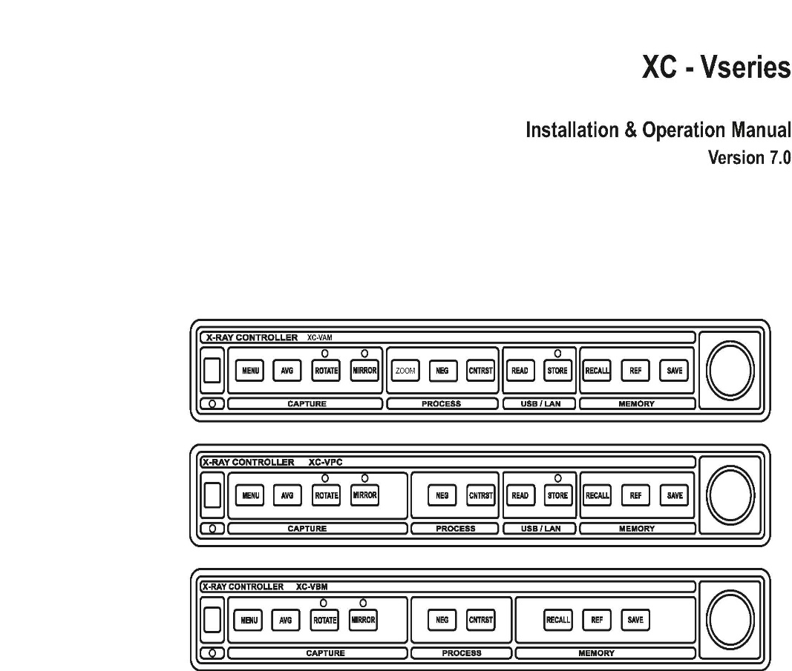

INDEX

Page no

A. Introduction 2

B. Interface details 5

C. Installation 9

**D. Powering up and Basic features of XC-V. 10**

**E. User interface 16**

F. Operation 18

G. LAN Interface 32

H. Software Installation 34

A. INTRODUCTION

Model Name : XC-VAM / XC-VPC / XC-VBM

XC-V series, X-ray image memory / controller is a state of the art fluoroscopy image memory and controller to capture, process and display X-ray images. This helps to avoid continuous exposure of the patient to X-ray for prolonged periods during fluoroscopy examinations. Advanced features include real time rotation, Non volatile permanent image storage and Image backup directly to USB flash drives or over LAN to a storage PC.

***Display:***

* Supports dual VGA monitors for flicker free display or CCIR monitors (selectable by switch in the back panel)
* Real time Image Rotation and Mirror
* On Screen Display (OSD) text on both monitors

***Image Capture:***

* High Resolution Image Capture at 768 pixels X 576 lines.

9 bit capture resolution.

***Processing:***

* Real time Noise Reduction by temporal averaging 2/ 4/ 8/ 16 frames.
* Real time Negative, Interactive Contrast Stretching

***Memory***

* On board storage capacity for 25 images which can be displayed one after the other on the 2nd monitor ; expandable to 100.
* Additional REF image display on 2nd monitor by using a dedicated key.
* Non volatile storage of images which are moved to 2nd monitor (images are retained in the memory even after a power failure).
* **Backup Options** (not available for XC-VBM)
  1. USB: ***USB Flash Drive (Memory stick)*** support for saving up to 1000 image files on a 512 MB memory stick. Memory stick can be subsequently plugged into a PC to transfer the image files to the Hard Disk, CD/DVD etc
  2. LAN: 10/ 100 Base T LAN support to transfer images to and fro from a PC

***Interface***

* Opto-isolated X-ray control interface to connect with standard C-Arm.
* Rotary dial on keyboard provides easy image management
* Infra Red Remote Unit to perform all functions of key board.
* USB 2.0 memory stick for image file transfer (not available for XC-VBM).
* Optional 10/100 Base T LAN for image transfer to PC for archiving, printing (not available for XC-VBM).

**Technical Specifications**

Video input : 1Vpp / 75 ohms, CCIR 625 lines, 50Hz

Resolution : 768 X 576, 9 Bit

Sampling Frequency : 14.75 MHz

Video bandwidth : > 6 MHz

Line Resolution : Better than 40 lines/ inch

Display VGA resolution : 800x600 x 75Hz refresh rate, Non-

interlaced

CCIR Display : 1Vpp, 75 ohms, CCIR 625 lines, 50Hz,

interlaced

Pixel Depth : 256 grey levels

Capture time : Real-time (1/25th of a Second)

Frame Averaging : 2/ 4/ 8/ 16 frames (in real-time)

Computer Interface : 10/100 Base T Ethernet (not for XC-VBM).

USB interface : USB2.0. full speed (not for XC-VBM).

Power : 220V AC, 50 Hz,10 watts

Dimension : (in cm) Length:31, Depth:25.50, Height:6

Weight : 3 Kg

|  |  |  |  |  |
| --- | --- | --- | --- | --- |
| **Features** | **XC-VAM** | **XC-VPC-LAN** | **XC-VPC** | **XC-VBM** |
| Rotation & Mirror | Yes | Yes | Yes | Yes |
| VGA output | Yes | Yes | Yes | Yes |
| CCIR output | Yes | Yes | Yes | Yes |
| Frame nos. | 25 / 100 | 25 / 100 | 25 / 100 | 25 |
| Permanent storage | Yes | Yes | Yes | NO |
| USB–Pen drive support | Yes | Yes | Yes | NO |
| LAN | optional | Yes | NO | NO |
| Zoom 2x, 3x | Yes | NO | NO | NO |

**Comparison between XC-VAM, XC-VPC & XC-VBM models**

**B.INTERFACE DETAILS**

**Video Interface**

The memory unit has one Video input and two sets of video outputs.

The 2x CCIR ( 625 /50Hz) - video output signals are available in two BNC connectors at the rear panel.

2 x VGA (800 x 600, 75Hz ) signals are available on two 15 pin mini Dsub connectors at the rear panel.

Video cable connections are shown in Figure 2.



Figure 2 : Video Connections for Memory Unit

Video input from CCD camera should have 75 ohms source impedance and video monitors should have 75 ohms input impedance.

The type of display is switch selectable from the rear panel.

Only one type of display ( either CCIR or VGA) should be connected at a time to the XC-V memory unit **( Simultaneous loading by VGA & CCIR monitors will result in intensity variations and may cause damage to the unit)**.

# Control Interface

Normally C-Arm X-ray systems are controlled through a foot-switch. This foot-switch could be used to control the memory unit in addition to the C-Arm X-ray machine.

**X-ray Interface Timing**

In the C-arm operation, when Foot switch is pressed, X-ray should turn ON and Live image should be displayed on the XC-V monitor. XC-V should capture the last image when the foot switch is released.

For the Capture operation to take place properly, the X-ray should remain ON when foot switch is released, and after the capture operation, X-ray should be turned OFF. This timing requirement is very important to get good quality images.

XC-V has built-in Interface timing feature, when used with an external Relay module as given below

**Interface option-1**

***This is the standard option.***

In this method XC-V is used with a relay Module (RM), as shown below.



RM is connected to the XC-V (X-ray interface connector) using the D-sub 25 pin cable.

The Foot switch is connected to the RM, and Relay contacts of the RM are used to control the X-ray inside the C-Arm unit.

Only a passive foot switch should be connected to the RM.

**Note: Application of any voltage to the Foot switch inputs will cause permanent damage to the unit.**

RM requires external 24VDC supply for operation.

When Foot switch is pressed, X-ray turns on and live image is displayed on the XC-V. When foot switch is released, XC-V captures the image and turns OFF the X-ray. The required timing requirements are met by the XC-V.

**Interface option-2**

***This interface option is a factory setting ( cannot be changed in the field). Contact factory for this option.***

In this method the timing requirements should be met by the C-Arm electronics and only Image Capture command is given to the XC-V.

The capture command input is a Voltage free NO ( Normally open) contacts, on the D_25 interface connector on the XC-V as shown below.



***Note: Application of any voltage to the control inputs will cause permanent damage to the unit.***

When control input is closed, live image will be displayed, and when released the Last image is captured. ( X-ray should be ON, for further 80ms, even after the contact is released, and this timing requirement should be met by the external C-Arm electronics)



**Note: pulse mode will not function in this interface mode.**

C. INSTALLATION

*Before installing the memory unit, connect the video output of the C-Arm directly to a CCIR video monitor. Apply power and activate the foot-switch to check whether the C-Arm and monitor are working properly.*

**Rear Panel Connections**



*Figure 5 : Rear Panel Connectors on the Memory Unit*

The function of each connector at the rear panel of the unit is as follows.

**1. LAN connector:** This is the Ethernet interface to a PC.

(only available for XC-VPC-LAN and above models)

**2. RS232C Connector:** This connector is for factory use.

**3. Video-in BNC Connector:** The video signal (CCIR 625lines / 50Hz) input connector ( connected from C-ARM camera output).

**4. X-Ray Interface connector:** This 25 pin D-Sub(Female) connector is connected to the Relay module ( ***interface option-1***) or can be used to control image capture directly in ***interface option-2.***

**5. Video out BNC connectors:** These two are CCIR standard video output connectors.

**6. CCIR/ VGA selection switch:** This selection switch is used to select the Video output standard as VGA or CCIR.

**7. Video out 15 - Dsub Connectors:** These two are VGA video out connectors. (Any standard VGA monitor can be used)

**8. Power connector:** AC Mains input power connector.

( 170-240VAC voltage range, 50-60Hz)

**D. POWERING UP & BASIC FEATURES OF XC-V**

**Powering up:**

When system is switched ON XC-V boots up and ‘Blinking mirror LED’ indicates the booting operation which may take up to 30 seconds. Subsequently images are loaded from internal non-volatile storage, and message “Loading Image” appears on the monitor (not applicable for XC-VBM).

*Note: If the system fails to boot up, a continuous beep is heard.*

After successful booting, Monitor1 shows a bar pattern. The multi gray bar pattern is used to do any brightness and contrast adjustments on the monitor.



Monitor2 shows any loaded image from the non – volatile memory present during last power OFF.(not applicable for XC-VBM).

The image Number ("01" to "25" or “REF”) is displayed on the top monitor2.

***Video Monitors***

**XC-V** supports 2 monitors as described above.

***LIH monitor*** ( Monitor 1 ) is used to display Live/ LIH - captured images). All images saved by foot switch operation ( in LIH mode) are saved to this monitor.

***Monitor-2*** is used to display any of the 25 ( 100 optional) images from the built in image memory of the unit.

**Image selection on Monitor-2:** Under normal operation of the memory unit, the rotary dial can be rotated ( left / right) to select images on the Monitor-2 and the image number is shown on top of the screen. ( image numbers 1-25 [or 100] & REF is displayed on top of the monitor)

***SAVE & RECALL operations***

***( LIH monitor <> Monitor-2, image transfer operations)***

At any time, the images on the LIH monitor can be transferred to Monitor-2 by pressing the ***SAVE*** key.

The image can be transferred back from Monitor-2 to LIH monitor by pressing the ***RECALL*** key.

***“REF Image KEY”***

REF image is a reserved location on the Monitor-2.

Advantage of this reserved memory is that,

1.It can be displayed on Monitor-2 any time by pressing the ***REF key.***

2. It is not over written in pulse mode of capture operation.

***Non volatile ( Permanent) memory operation***

( XC-VPC and higher models)

For XC-VPC and higher models, all images transferred to Monitor-2 are also automatically saved to an internal Non-Volatile memory.

On power up, all these (25/100) images are automatically restored from the non volatile memory. Also, after power failures, the images are restored automatically without any corruption.

***(In pulse mode this permanent memory storage operation has to be initiated manually )***

***Image BACK-UP operation***

It is always necessary to back up the images stored in XC-V units. For this, two options are available 1. Via USB, 2. Via LAN

**In USB option**:

***Storing an image to Pen DRIVE***

A USB pen drive can be connected to the USB connector on the front panel of the unit. The ***STORE key*** can be used to save any images displayed on **LIH-Monitor** to the pen drive.

The images stored in the pen drive are ***sequentially numbered (File-No)***, along with time stamp. Storing is always done to next sequence number, so as not to affect already stored images.

***Reading an image from the Pen drive:***

***READ key*** can be used to read images from the pen drive to the **LIH – Monitor.** The image **FILE-No** to be READ from the pen drive can be edited / selected by the user ( the time stamp is also displayed along with FILE-No when image is read from the pen drive)

**In LAN option**:

For transfer of images to / from a PC over LAN, the **XC-IMAGER** s/w application, **should RUN on the PC, and XC-V should be connected to the PC**.

Refer s/w reference guide for details.

***Transferring images to LAN connected PC:***

The ***STORE key*** can be used to save any images displayed on **LIH-Monitor** to the LAN connected PC and these images appear on the PC monitor.

The images sent to the PC are saved in the directory set by the user.

***Reading an image from a LAN connected PC:***

***READ key*** can be used to read images from the PC to the **LIH– Monitor.** The image to be READ from the PC can be selected by the user from a directory set by him.

***Figure showing different types of image transfer operations***



***PULSE-Mode (CINE mode):***

Pulse mode is used to capture images in succession, so as to record a sequence of images in a procedure.

In this mode, X-ray is pulsed (turned ON and OFF at regular intervals) when the foot-switch is kept pressed ( as shown below). Each time the X-ray goes OFF, a new image gets captured into the next memory location. Memory location REF is not overwritten.

The Pulse Rate can be set by clicking Rotary dial in pulse mode “LOW”,“MEDIUM” or “HIGH” on monitor1. This is the rate at which images are captured in PULSE mode.



“LOW” PULSE rate causes the slowest operation (with longest X-ray off-time between successive captures) and “HIGH” causes the fastest operation.

With “**HIGH” rate selection, X-ray is kept continuously on** and images are captured as fast as possible with the current frame average setting.

******Note: In the PULSE mode, the X-ray images are updated ( as they are captured) on both the monitors.

***Note: the pulse captured images are not automatically saved to the internal Non-volatile memory.***

After pulse capture, when foot switch is released, “Press save for Backup” message appears on the screen (not for XC-VBM). Press SAVE key to backup the pulse captured images to non-volatile internal memory. (A new foot switch or key press operation skips this SAVE operation)

**E. USER INTERFACE**

# Description of Front panel

## Keyboard

On the front panel, the keys are grouped into four functional groups: (from left to right) the CAPTURE, PROCESS, USB/LAN and MEMORY groups. A valid key press produces a “short beep” sound from the buzzer, while an invalid key produces a “long beep”. In addition, an infrared (IR) detector is present on the front panel.

## XC-VBM model



**XC-VPC model**



**XC-VAM model**



**ROTARY DIAL :**

A rotary dial is present on the right side of the front panel. This is used as a flexible input device to change images on the REF monitor, adjust rotation, or edit parameters in the system configuration.

The Rotary Dial is similar to the tuning control knob on a Radio, and can be rotated clockwise or anti-clockwise. The Dial could also be depressed ( **CLICKED**) to perform certain operations. Each of these operations (turning clockwise, anti-clockwise or clicking) has special meanings depending on the operating context.

**USB connector:** A USB2.0 full speed connector is present on the front panel to connect pen drives for storing / reading captured images.

##### INFRA-RED (IR) REMOTE

The keys on the IR remote are essentially the same as those on the front panel. The main differences are: on the IR remote, the Rotary Dial functions are carried out by the four arrow keys at the bottom.

The **left and right arrow keys** on IR remote, produce the same effect as **rotating** **the Dial** in an anti-clockwise or clockwise direction.

**up or down arrow keys** simulate the **CLICK** function of the dial.

###### F. OPERATION

**1.MENU KEY**

Menu key is used to select the operating mode. The MODE is cycled as LIH -> LIVE -> PULSE -> CONFIG and LIH again.

Present mode is displayed in Monitor1.

**LIH (Last Image Hold)-Mode**:

When the footswitch is pressed, X-Ray is turned ON and live real time image is displayed. When foot switch is released, last image is frozen on the screen. LIH is the default mode on power up.

**LIVE-Mode:**

The live image is shown when X-ray is ON , but image is **not captured** when the footswitch is released.

This mode can be used to compare the live image against an image captured earlier ( on the LIH Monitor)

**PULSE-Mode:**

In this mode X-ray is pulsed and images are captured in a sequence.

The Pulse Rate can be set by clicking Rotary dial. “LOW”, “MEDIUM” or “HIGH” on monitor1. (This rate also depends on the number of video frames averaged for noise reduction )

“LOW” PULSE rate causes the slowest operation (with longest X-ray off-time between successive captures) and “HIGH” causes the fastest operation.

With “HIGH” rate selection, X-ray is kept continuously on and images are captured as fast as possible with the current frame average setting.

**Configure-Mode:**

This is to set the different configuration of the system such as File back up mode, IP address setting for LAN, Date & Time setting and blanking circle position setting.

To enter this mode, select CONFIG by MENU key and **CLICK** rotary dial. ( as shown below)

LIH Monitor

**CONFIG**

**ROTN:000**

**AVG:04**

**Click to config**

**X-RAY OFF**

Turning the Rotary dial cycles through sub menus FILE -> IP -> TIME -> CIRCLE-> and FILE again. **Click** rotary dial to enter the required **sub menu.**

***sub menu: FILE:***

**FILE**

**ROTN:000**

**AVG:04**

**USB**

**X-RAY OFF**

This mode selects the **default back up mode** of the XC-V. ( USB pen drive or LAN).

When FILE is displayed, **Click** rotary dial to enter this mode as shown above. Rotate rotary dial to select file back up setting as USB or LAN.

Press menu key / click rotary dial to exit this mode.

(not applicable for XC-VBM).

***Sub menu: IP setting:***

**IP**

**ROTN:000**

**AVG:04**

**192.168.002.101**

**X-RAY OFF**

From CONFIG mode, select IP and **click** encoder to enter this

sub-menu.

IP address consists of four numerical **address fields**.(192, 168, 002, 107 in the above image).

**These address fields start blinking indicating user EDIT mode.**

Rotate dial to select the field to be modified.

While rotating the rotary dial, first numeric field gets modified. Press rotary dial to save this field and to jump to next fields.

Fifth rotary dial **Click** will save the values to the XC-V unit. ( press MENU key anytime, to escape without saving , before fifth press).

After editing all fields, the caption “IP Saved. Restart” will be displayed for 3 seconds (as shown below). The unit has to be restarted to effect the changes by removing and re-applying power.

**IP**

**ROTN:000**

**AVG:04**

**IP saved, Restart**

**X-RAY OFF**

***Sub menu: Time setting:***

**Time**

**ROTN:000**

**AVG:04**

**2008.01.01 – 01:01:01**

**X-RAY OFF**

Select Time sub menu from config. mode and change the time as in the previous procedure. (YYYY.MM.DD – HH:MM:SS, YYYY-Year, MM-Month, DD-Date, HH- hour in 24hr. format, MM-minutes, SS-Seconds)

***Sub menu: Circle:***

From CONFIG mode, select **CIRCLE** and **click** encoder to enter this sub-menu.

**CIRCLE**

**ROTN:000**

**AVG:04**

**x =126 : y =25 : r =139**

**X-RAY OFF**

This mode is for adjusting the radius(size) & centre(position) of circular-window on the screen.

Capture a new image to show the circular window.

For Radius : use RECALL and REF keys (Range: 99 to 139)

For X direction : use ROTATE and MIRROR keys (Range: 72 to 177)

For Y direction : use NEG and CNTRST keys (Range: 22 to

27 for r=139 / 107 for r=99)

(PRESS MENU to abort this operation if required.)

To save the settings Press SAVE key.

The unit has to be restarted by removing and reapplying power (**RESTART** message is displayed on the screen).

***Important note:***

It is recommended to do this CIRCLE setting operation, at the time of installation only. (Changing the circle causes circular window to be improperly displayed for earlier saved images.)

It is recommended to note down the old x, y & r values, before attempting a change.

WE STRONGLY RECOMMEND THAT RADIUS BE KEPT AT MAXIMUM (139) AND CAMERA ZOOMED TO COVER THE FULL CIRCLE SO THAT IMAGE DETAILS ARE CLEARLY SEEN. FOR EXAMPLE, REDUCING THE RADIUS TO 125 HAS THE EFFECT OF COMPRESSING THE IMAGE TO 90%.

**2. AVG Key**

This key sets the number of video frames averaged for noise reduction (1, 2, 4, 8 or 16). Successive depression of this key changes the value.( default 4)

**3. ROTATE Key**

This key enables the Image rotation operation. Rotation is possible on the LIH monitor only. The LED above this key lit when this mode is selected.

The default rotation angle step is 20 degrees, Clicking the encoder dial, changes the step angle to 2 (or 1 depending on model) degrees (and back to 20 degrees).

**4. MIRROR Key**

This is to view the Mirror view of the image displayed on the LIH monitor. The LED above this key is lit when this mode is selected.

Mirroring is applied only on real time live images or images captured directly on the LIH monitor.



**Mirror is not applied** for any images transferred from Monitor-2 ( by RECALL key ) or by READ operation from USB / LAN.

**5. NEG Key**

This (NEGATIVE) key is used to show gray scale negative of images displayed on the monitors. (Press the NEG key again to display the normal image.)

**6. CNTRST Key**

**(CNTRST) Contrast Processing**

Image is captured with 256 levels (values 0-255) of grey scales (brightness levels). Contrast processing operation involves stretching a portion of the Grey scale ( say between 30 & 80) to full brightness range so that the detailed information in this range is amplified and displayed.

This improves visibility of fine and hidden image details.

Press "Contrast" key to enter this mode , when following screen appears with a **Contrast Slider.**



The shaded region of **SLIDE BAR** shows the portion of the image being stretched / enhanced.( extreme left side of the bar indicates image brightness of 0 ( black) and right most end indicates image brightness of 255 ( white).

This shaded region can be expanded / reduced OR moved within the intensity region of image/ slider bar.

Steps for this operation is as follows,

1. Press "CONTRAST" key to enter this mode.

2. Rotate encoder ( left / right) to move position of the shaded region.

3. CLICK encoder and rotate to change width of shaded region

4. CLICK encoder again to and rotate to change position of shaded region.( as in STEP 3.)

5. Repeat steps 3 & 4 to select region of interest / scan the grey scale information in the X-ray images.

Press the CONTRST key again to exit from interactive contrast enhancement mode.

**7. SAVE key**

This key is used to save the image on LIH Monitor to the current memory location on the Monitor-2( image numbers 01 to 25 (100) or REF image). For XC-VPC and above models the image is also transferred to the permanent image storage.

**8. RECALL Key**

The RECALL key is used to transfer the image displayed on Monitor-2 to LIH Monitor ( applicable only when X-ray is OFF / Foot switch is released).

This key can be used to selectively bring images from monitor-2 to LIH monitor and then to STORE them to USB/LAN.

**9. REF Key**

REF image is a reserved location on the Monitor-2.

Advantage of this reserved memory is that,

1.It can be displayed on Monitor-2 any time by pressing the ***REF key.***

2. It is not over written in pulse mode of capture operation.

**10. Zoom key ( only for AM models)**

Press ZOOM key to activate ZOOM Mode. Two levels of zoom **X2 and X3** are available, which can be selected by repeated key press and it will be displayed at the right hand bottom side of LIH- monitor. The third key press exits from this mode.



Available only for LIH images.

In zoom mode the rotary dial is used to select the area of interest by horizontal and vertical PAN . A click in rotary dial will switch between horizontal and vertical pan in this mode. ( displayed **as H Pan or V Pan)**



***Note: In ZOOM mode following operations will result in exit from ZOOM mode. - Menu, Rotate, Mirror, Read, Store, Recall and Save.***

**11.READ and STORE Keys (Image store & Retrieval operations- not for VBM models)**

#### USB –pen drive



**Note:**

**For this the File option in CONFIG.Sub menu should be = USB.**

*(images in the pen-drive are sequentially numbered (****3 digit FILE-No****) with a Time stamp (Yr.Mo.Dt. Hr.Min. Sec). This image number can be used as a reference number, to READ the images from a PC or from the XC-V itself)*

**Storing images to USB – Pen drive:**

1. insert USB- pen drive into the front panel. ***(after inserting a drive wait for 15 seconds before doing a read / store operation***)
2. Press “ STORE” key.
3. Message “STORE USB” Is displayed, and image on the

***LIH-Monitor*** is saved to next available sequential **FILE Number.**

(STORE key – LED also lights during this period).

***Note: do not remove the pen drive during this period.***

1. After successful operation, the image FILE-No. and time stamp is displayed) as below.

**LIH**

**ROTN:000**

**AVG:04**

**003: 2007 DEC 15 01:10:20**

**X-RAY OFF**

***003 = File No of image in USB*** ( followed by time stamp)

***If USB is not inserted / detected properly following message occurs.***

**LIH**

**ROTN:000**

**AVG:04**

**Re-Insert Drive – wait 15 sec**

**X-RAY OFF**

**LIH**

**ROTN:000**

**AVG:04**

**USB absent**

**X-RAY OFF**

( after inserting / re- inserting the pen drive wait for

***15 seconds*** before doing next operation)

**Reading images from USB – Pen drive:**

1. insert USB- pen drive into the front panel - USB connector ***(after inserting a drive, wait for 15 seconds before doing a read / store operation***).
2. Press “ READ” key. Following screen appears, with a ***blinking Image FILE-No. ( 003 in following figure)***

**LIH**

**ROTN:000**

**AVG:04**

**File : 003**

**X-RAY OFF**

1. User may EDIT the FILE-No, using Rotary Dial.

Rotate Dial to change the first digit, press encoder to move to the next etc.

After editing 3rd digit, click dial again to start Read operation.

1. Image is read from the Pen drive and is displayed on the *LIH-monitor*. The **Time stamp** of the image along with the **FILE-No** is displayed on the monitor as shown below



***Note: do not remove the pen drive during this period***

1. Read operation can be aborted by pressing the **MENU key**.

**LIH**

**ROTN:000**

**AVG:04**

**003: 2007 Dec 20 02:02:20**

**X-RAY OFF**

***(if USB is not inserted / detected properly, an error message is displayed as described earlier.)***

#### LAN image transfer



**Note: For initiating image transfer over LAN from XC-V, the File option in CONFIG. Sub menu should be = LAN. However, LAN transfer can be initiated from the PC under any setting.**

before LAN transfer, following conditions should be satisfied,

1. IP no: should be set properly in the XC-V CONFIG. – IP submenu.
2. PC - IP number should be set properly as in chapter E
3. The XC-V and PC should be on the same LAN network, physically connected via a LAN SWITCH, or directly as given in chapter F.
4. the XC-V application software **XC-IMAGER,** should be running on the PC.
5. connect the PC to the XC-V unit, by giving the connect command (after opening a directory on the PC with the required Patient ID).

**STORE operation (image transfer from XCV to PC)**

1. Press “ STORE” key.
2. Message “ Store LAN” is displayed, and image on the

***LIH-Monitor*** is moved to the PC, and is stored in the patient directory.

( Image will be saved at the set directory in PC in BMP format. )

**LIH**

**ROTN:000**

**AVG:04**

**Store LAN**

**X-RAY OFF**

If LAN is not connected, or s/w application is not running on PC or IP address is different, following message is displayed.

**LIH**

**ROTN:000**

**AVG:04**

**Waiting LAN**

**X-RAY OFF**

**READ operation (image transfer from PC to XC-V)**

1. Press “ RAED” key.
2. Message “ READ LAN” is displayed, and image on the Main window of the PC application s/w is moved to the ***LIH-Monitor***.

**LIH**

**ROTN:000**

**AVG:04**

**READ LAN**

**X-RAY OFF**

*( if LAN connection is not established before doing the STORE / READ operations “ W****aiting LAN****” appears on the monitor)*

**G. LAN INTERFACE (not for XC-VBM)**

Physical connection between X-Ray controller and a computer / computer network is by means of a LAN cable. It is to be connected to the LAN connector provided at the rear side of X-Ray controller. Please note that the type of cable will vary according to the LAN connection as shown below.

X-ray controller can be connected to a computer in two ways as below.

1. X-Ray Controller directly to a single Computer.
2. X-Ray Controller to a computer or LAN network by using a hub / Switch / Router.

For a dedicated LAN connection (X-Ray controller and a single computer) ‘cross wired’ cable should be used as shown in Fig. If it is to be connected by using a Hub / Switch / Router a standard LAN cable can be used. Consult your PC supplier for more details.



Fig. XC-V to PC, Direct LAN connection ( Using Cross wired cable)



**Note: It is important use cross wired cable for direct PC connection**



Fig. XC-V connection to a LAN network by using a hub / Switcher / Router

**H. SOFTWARE INSTALLATION**

The CD supplied along with X-Ray controller contains the software for installation in your PC **( XC-IMAGER).** Once inserted in the CD drive, it will ‘Autorun’ and install the software. During installation, it will prompt for the directory where the software is to be installed and the images are to be stored.

1. To connect the X-Ray controller unit on a LAN network, the X-Ray control unit should have an unused network IP address assigned to it.
2. In a multiple PC networked facility, find out the unused IP address from the network administrator and enter it on the X-Ray Controller unit as described in XC-V CONFIG : IP sub menu.

3.Setting IP address to the PC

a.From ***Start*** menu select ***Control Panel.***

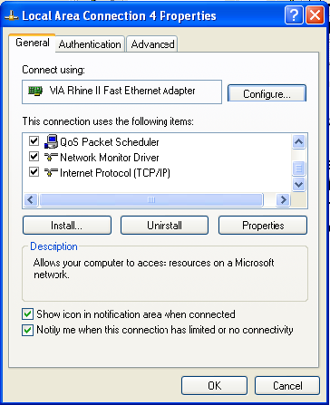b.Open ***Network Connections***. Right click on ***Local Area Connection*** and select ***Properties***. A dialog box like the one given below will appear.

1. Select ***Internet Properties (TCP/IP)*** and click on ***Properties***. Another dialog box appears.

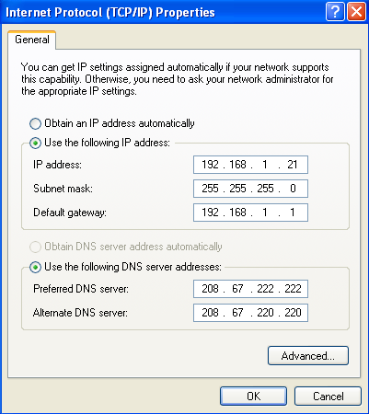

Here, IP address and Subnet mask have to be set. For a Subnet mask 255.255.255.0, the first 3 values for the IP address must be the same for XC-VPC and the PC. That is, if the IP address for XC-VPC has been set as, say 192.168.2.101, IP address for the PC can be any value in the range 192.168.2.1 to 192.168.2.254 **except** 192.168.2.101 itself**.**

Enter the desired IP value and click OK.

**Connection details only for XC-VAM-HD-720P**

**a. HD-720P output selection:**



For selecting HD-720P standard, select the toggle switch provided at the back panel of XC-VAM–HD 720P to the right (HDTV) position. The switch positions are shown in the figure above. Please note that each time you change the position, the unit has to be switched OFF and powered ON again to effect the selection.

**b. HD-720P Connection:**

Connect an RCA cable (standard audio video connecting cable) to the RCA connector provided at the rear side of the XC-VAM-HD-720P unit, written as HDTV to get the output from the unit. The other end is to be connected to the ‘Y’ input of the component input available with the TV unit. Two nos. of 75 Ohm terminations for RCA are supplied for XC-VAM-HD-720P for plugging in the other inputs ‘R-Y’ (‘Pr’) and ‘B-Y’ (‘Pb’) of the LCD TV.

Video output of the XC-VAM-HD-720P unit (BNC output) should be left free to avoid double termination.

**c. Input selection on TV:**

Select the component input for video source by using the remote controller. Some LCD TV may have more than component input, connection and input selection has to be done accordingly.

NOTES

NOTES

NOTES